Lab06 云计算：基于ModelArts的模型训练与部署

实验背景
本实验以Yolov8模型为例，介绍如何将Yolov8模型迁移至ModelArts上，并在GPU环境进行训练。
学习视频：
AI开发流程：https://support.huaweicloud.com/video/modelarts-1724844549870936776.html
ModelArts：https://support.huaweicloud.com/video/1668414834279893472.html
OBS：https://support.huaweicloud.com/video/obs-1725543099823638831.html

实验步骤
操作前提：登录华为云，并完成实名认证。

任务一：环境准备

步骤1 使用OBS桶进行储存管理
- 通过如下链接进入OBS对象存储服务：https://console.huaweicloud.com/console/?region=cn-north-4#/obs/manager/dashboard
- 创建桶
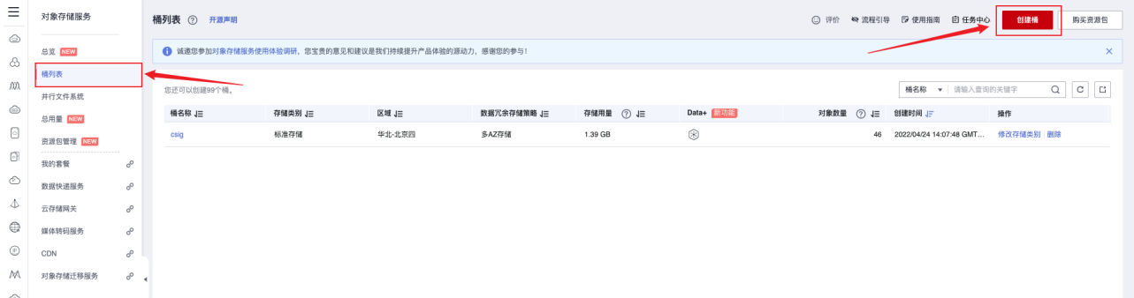

桶名称可以自定义，区域选择华北-北京四，其他设置可以保持默认或按需修改
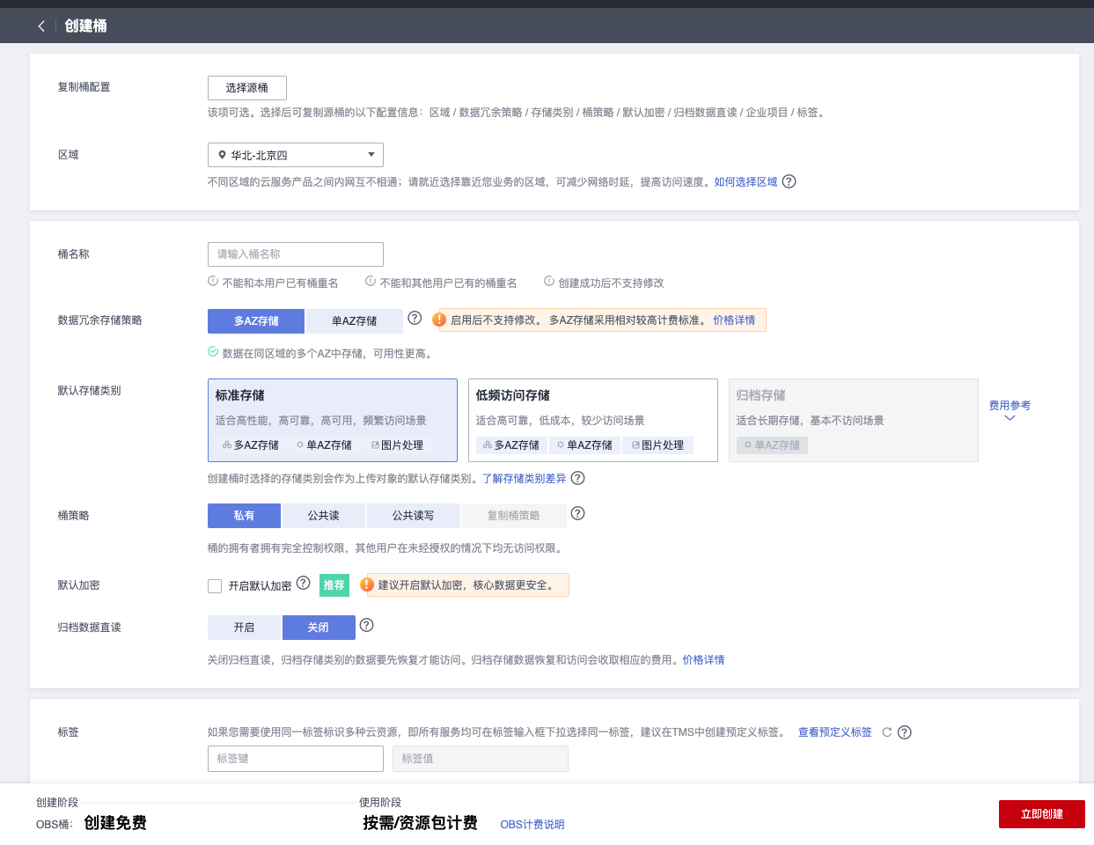

- 创建好以后，记住刚刚创建的桶名，例如ll-test，则后续可以通过obs://ll-test对它进行访问。

步骤2 在ModelArts管理控制台创建notebook
在ModelArts管理控制台左侧导航栏中选择“开发空间 > Notebook”，进入“Notebook”管理页面。
单击“创建”按钮，进入“创建Notebook”页面。
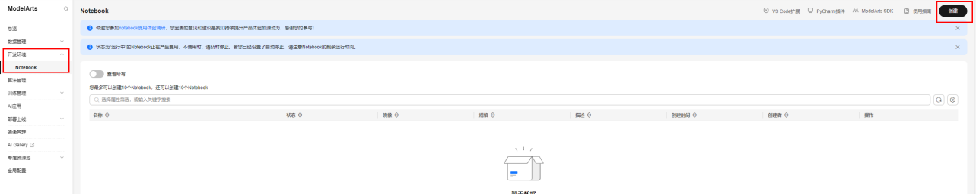

在创建notebook页面，按照如下参数进行配置：
名称：notebook-yolov8（可自定义）
自动停止：开启，2小时
镜像：pytorch1.8-cuda10.2-cudnn7-ubuntu18.04
资源类型：公共资源池
类型：GPU
规格：GPU: 1*Pnt1(16GB)|CPU: 8核 64GB
存储配置：云硬盘EVS，20G
SSH远程开发：不开启
点击“立即创建”，确认产品规格后点击“提交”，并返回。
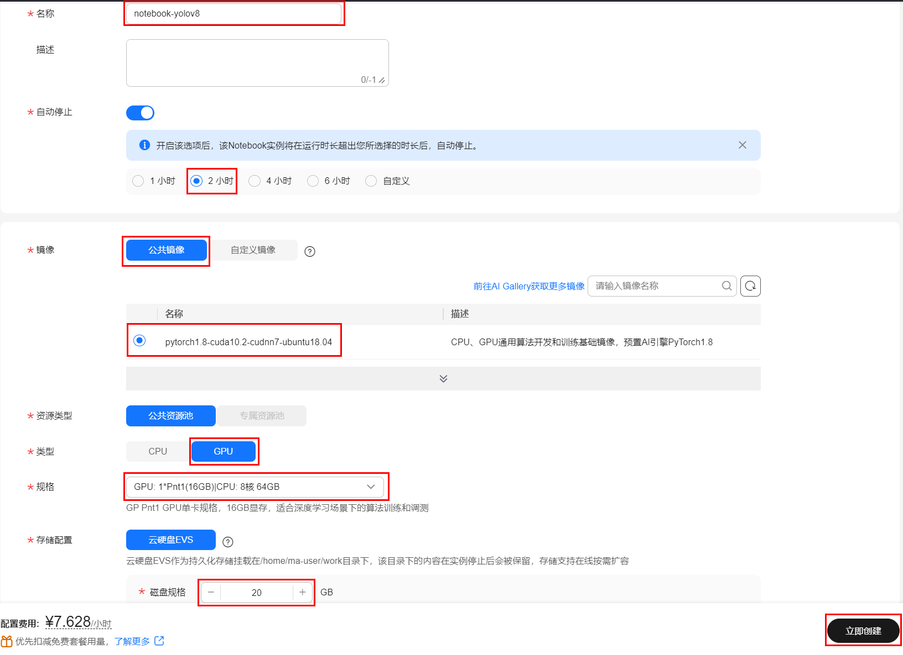

此时，notebook正在创建中，创建时长大约1分钟左右。

待notebook状态变为“运行中”，点击该notebook实例右侧“打开”，即可进入到jupyterlab环境中。

第一种创建方式：进入jupyterlab环境后，点击PyTorch1.8创建kernel为PyTorch1.8的ipynb文件。
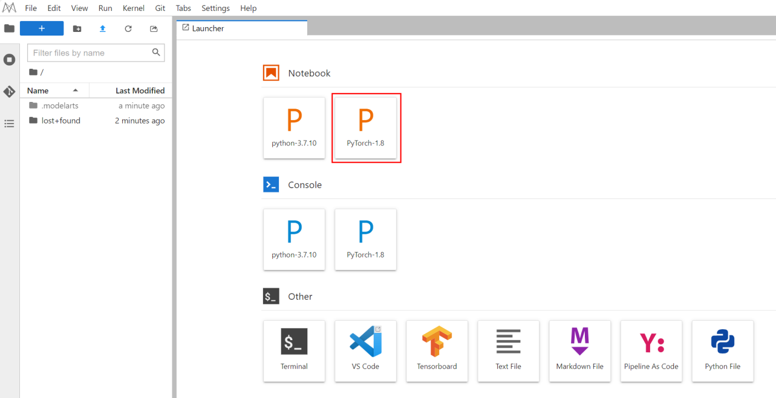
第二种创建方式：进入Notebook页面后，在打开的notebook页面左上角点击“+”号，点击Notebook进行创建，双击下方新的的Untitled.ipynb文件，弹出代码开发界面，如下图：
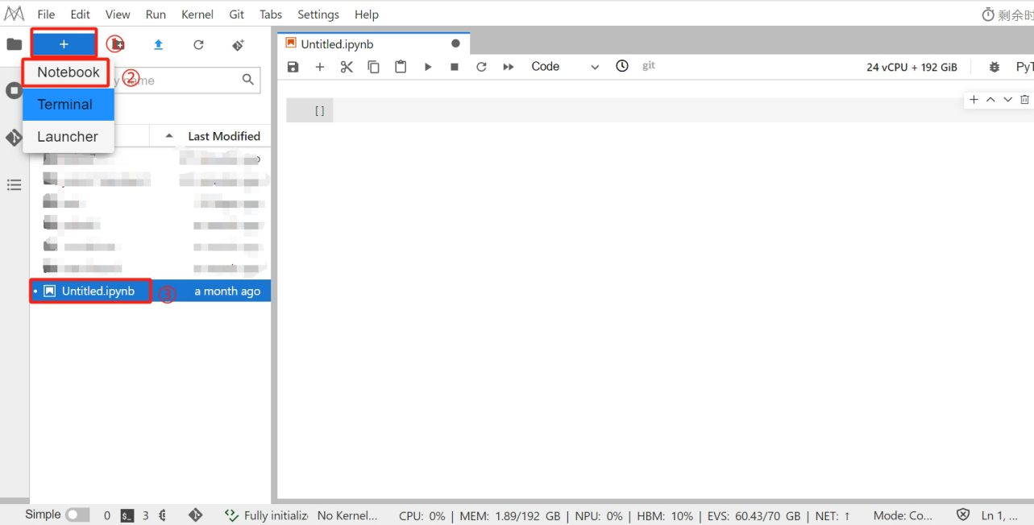

在代码开发界面添加代码可参考下图操作：
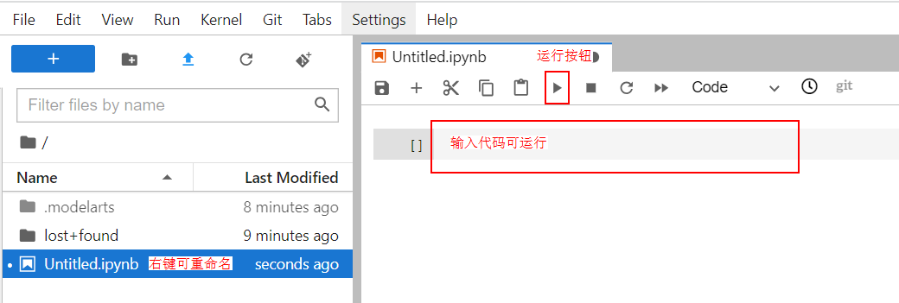

任务二：Yolov8在线训练

步骤1 数据集准备
- 下载数据集
本案例数据集基于DeepPCB数据集整理得到，训练集有1000张图片，验证集500张图片，包含6种PCB检测缺陷：0-open, 1-short, 2-mousebite, 3-spur, 4-copper, 5-pin-hole
输入：
import moxing as mox
mox.file.copy_parallel('obs://modelarts-labs-bj4-v2/case_zoo/yolov8_pcb/pcb_data','pcb_data')
输出：
INFO:root:Using MoXing-v2.1.0.5d9c87c8-5d9c87c8
INFO:root:Using OBS-Python-SDK-3.20.9.1
INFO:root:Listing OBS: 1000
INFO:root:Listing OBS: 2000
INFO:root:Listing OBS: 3000
INFO:root:1000/3002
INFO:root:2000/3002
INFO:root:3000/3002
- 查看数据集
输入：
import os
import random
import cv2
import numpy as np
from matplotlib import pyplot as plt
%matplotlib inline
classes = ["open", "short","mousebite","spur","copper",'pin-hole'] # 类别
file_path = "pcb_data/images/train2017"
file_list = os.listdir(file_path)
img_paths = random.sample(file_list, 4)
img_lists = []
for img_path in img_paths:
img_path = os.path.join(file_path, img_path)
img = cv2.imread(img_path)
h, w, _ = img.shape
tl = round(0.002 * (h + w) / 2) + 1
color = [random.randint(0, 255) for _ in range(3)]
if img_path.endswith('.png'):
with open(img_path.replace("images", "labels").replace(".png", ".txt")) as f:
labels = f.readlines()
if img_path.endswith('.jpg'):
with open(img_path.replace("images", "labels").replace(".jpg", ".txt")) as f:
labels = f.readlines()
for label in labels:
l, x, y, wc, hc = [float(x) for x in label.strip().split()]
x1 = int((x - wc / 2) * w)
y1 = int((y - hc / 2) * h)
x2 = int((x + wc / 2) * w)
y2 = int((y + hc / 2) * h)
cv2.rectangle(img, (x1, y1), (x2, y2),
color, thickness=tl, lineType=cv2.LINE_AA)
cv2.putText(img,classes[int(l)],(x1,y1-2), cv2.FONT_HERSHEY_SIMPLEX, 1, (0,111,222), 3, cv2.LINE_AA)
img_lists.append(cv2.resize(img, (1280, 720)))
image = np.concatenate([np.concatenate(img_lists[:2], axis=1), np.concatenate(img_lists[2:], axis=1)], axis=0)
plt.rcParams["figure.figsize"] = (20, 10)
plt.imshow(image[:,:,::-1])
plt.axis('off')
plt.show()
输出：
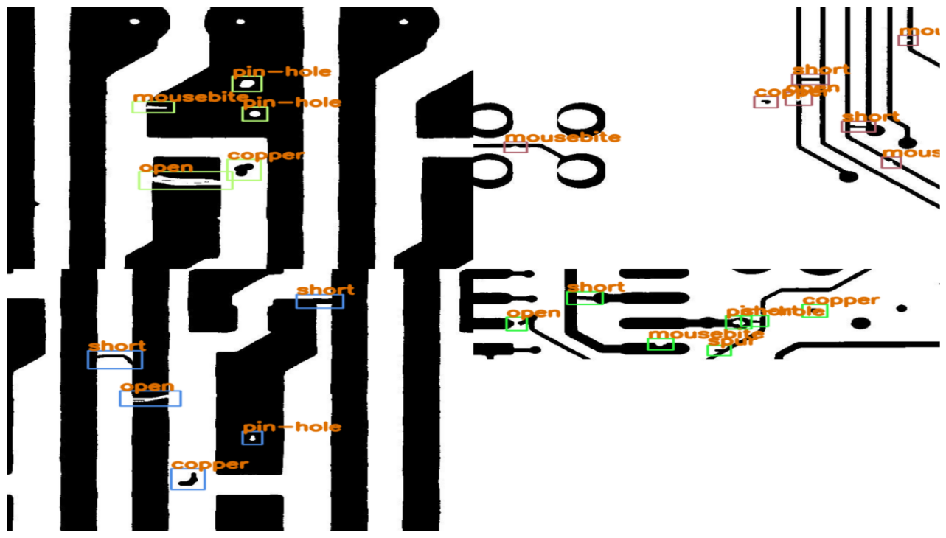

步骤2 下载代码并安装依赖库
本案例代码基于GitHub上Yolov8代码修改得到。
- 下载代码和模型
import moxing as mox
mox.file.copy_parallel('obs://modelarts-labs-bj4-v2/case_zoo/yolov8_pcb/code','code')
运行完成后，代码左侧会显示运行耗时。
- 安装依赖库
输入：
!pip install ultralytics==8.0.109
!pip install numpy==1.20.0
输出：
Looking in indexes: http://repo.myhuaweicloud.com/repository/pypi/simple
Collecting ultralytics==8.0.109
Downloading http://repo.myhuaweicloud.com/repository/pypi/packages/01/c0/0244acfee8eb19c59f8f07e6f21d7be5da4483f45f51d6bb2489c5f1c183/ultralytics-8.0.109-py3-none-any.whl (591 kB)
|████████████████████████████████| 591 kB 10.6 MB/s eta 0:00:01
Collecting PyYAML>=5.3.1
Downloading http://repo.myhuaweicloud.com/repository/pypi/packages/d7/8f/db62b0df635b9008fe90aa68424e99cee05e68b398740c8a666a98455589/PyYAML-6.0.1-cp37-cp37m-manylinux_2_17_x86_64.manylinux2014_x86_64.whl (670 kB)
|████████████████████████████████| 670 kB 25.0 MB/s eta 0:00:01
Requirement already satisfied: psutil in /home/ma-user/anaconda3/envs/PyTorch-1.8/lib/python3.7/site-packages (from ultralytics==8.0.109) (5.8.0)
Requirement already satisfied: tqdm>=4.64.0 in /home/ma-user/anaconda3/envs/PyTorch-1.8/lib/python3.7/site-packages (from ultralytics==8.0.109) (4.64.1)
Collecting seaborn>=0.11.0
Downloading http://repo.myhuaweicloud.com/repository/pypi/packages/8f/2e/17bbb83fbf102687bb2aa3d808add39da820a7698159302a1a69bb82e01c/seaborn-0.12.2-py3-none-any.whl (293 kB)
|████████████████████████████████| 293 kB 66.9 MB/s eta 0:00:01
Requirement already satisfied: scipy>=1.4.1 in /home/ma-user/anaconda3/envs/PyTorch-1.8/lib/python3.7/site-packages (from ultralytics==8.0.109) (1.5.2)
Requirement already satisfied: pandas>=1.1.4 in /home/ma-user/anaconda3/envs/PyTorch-1.8/lib/python3.7/site-packages (from ultralytics==8.0.109) (1.1.5)
Requirement already satisfied: matplotlib>=3.2.2 in /home/ma-user/anaconda3/envs/PyTorch-1.8/lib/python3.7/site-packages (from ultralytics==8.0.109) (3.5.1)
Requirement already satisfied: torchvision>=0.8.1 in /home/ma-user/anaconda3/envs/PyTorch-1.8/lib/python3.7/site-packages (from ultralytics==8.0.109) (0.9.0)
Collecting sentry-sdk
Downloading http://repo.myhuaweicloud.com/repository/pypi/packages/b3/aa/9f8dce2aec2e95d48c057ff3bcac48958cd15f67d4e9e80e74b46c324abf/sentry_sdk-2.16.0-py2.py3-none-any.whl (313 kB)
|████████████████████████████████| 313 kB 64.0 MB/s eta 0:00:01
Collecting opencv-python>=4.6.0
Downloading http://repo.myhuaweicloud.com/repository/pypi/packages/3f/a4/d2537f47fd7fcfba966bd806e3ec18e7ee1681056d4b0a9c8d983983e4d5/opencv_python-4.10.0.84-cp37-abi3-manylinux_2_17_x86_64.manylinux2014_x86_64.whl (62.5 MB)
|████████████████████████████████| 62.5 MB 15.7 MB/s eta 0:00:01
Requirement already satisfied: Pillow>=7.1.2 in /home/ma-user/anaconda3/envs/PyTorch-1.8/lib/python3.7/site-packages (from ultralytics==8.0.109) (9.3.0)
Requirement already satisfied: torch>=1.7.0 in /home/ma-user/anaconda3/envs/PyTorch-1.8/lib/python3.7/site-packages (from ultralytics==8.0.109) (1.8.0)
Requirement already satisfied: requests>=2.23.0 in /home/ma-user/anaconda3/envs/PyTorch-1.8/lib/python3.7/site-packages (from ultralytics==8.0.109) (2.27.1)
Requirement already satisfied: fonttools>=4.22.0 in /home/ma-user/anaconda3/envs/PyTorch-1.8/lib/python3.7/site-packages (from matplotlib>=3.2.2->ultralytics==8.0.109) (4.38.0)
Requirement already satisfied: cycler>=0.10 in /home/ma-user/anaconda3/envs/PyTorch-1.8/lib/python3.7/site-packages (from matplotlib>=3.2.2->ultralytics==8.0.109) (0.11.0)
Requirement already satisfied: pyparsing>=2.2.1 in /home/ma-user/anaconda3/envs/PyTorch-1.8/lib/python3.7/site-packages (from matplotlib>=3.2.2->ultralytics==8.0.109) (3.0.9)
Requirement already satisfied: python-dateutil>=2.7 in /home/ma-user/anaconda3/envs/PyTorch-1.8/lib/python3.7/site-packages (from matplotlib>=3.2.2->ultralytics==8.0.109) (2.8.2)
Requirement already satisfied: numpy>=1.17 in /home/ma-user/anaconda3/envs/PyTorch-1.8/lib/python3.7/site-packages (from matplotlib>=3.2.2->ultralytics==8.0.109) (1.19.5)
Requirement already satisfied: kiwisolver>=1.0.1 in /home/ma-user/anaconda3/envs/PyTorch-1.8/lib/python3.7/site-packages (from matplotlib>=3.2.2->ultralytics==8.0.109) (1.4.4)
Requirement already satisfied: packaging>=20.0 in /home/ma-user/anaconda3/envs/PyTorch-1.8/lib/python3.7/site-packages (from matplotlib>=3.2.2->ultralytics==8.0.109) (21.3)
Requirement already satisfied: typing-extensions in /home/ma-user/anaconda3/envs/PyTorch-1.8/lib/python3.7/site-packages (from kiwisolver>=1.0.1->matplotlib>=3.2.2->ultralytics==8.0.109) (4.4.0)
Requirement already satisfied: pytz>=2017.2 in /home/ma-user/anaconda3/envs/PyTorch-1.8/lib/python3.7/site-packages (from pandas>=1.1.4->ultralytics==8.0.109) (2022.6)
Requirement already satisfied: six>=1.5 in /home/ma-user/anaconda3/envs/PyTorch-1.8/lib/python3.7/site-packages (from python-dateutil>=2.7->matplotlib>=3.2.2->ultralytics==8.0.109) (1.16.0)
Requirement already satisfied: urllib3<1.27,>=1.21.1 in /home/ma-user/anaconda3/envs/PyTorch-1.8/lib/python3.7/site-packages (from requests>=2.23.0->ultralytics==8.0.109) (1.26.12)
Requirement already satisfied: charset-normalizer~=2.0.0 in /home/ma-user/anaconda3/envs/PyTorch-1.8/lib/python3.7/site-packages (from requests>=2.23.0->ultralytics==8.0.109) (2.0.12)
Requirement already satisfied: idna<4,>=2.5 in /home/ma-user/anaconda3/envs/PyTorch-1.8/lib/python3.7/site-packages (from requests>=2.23.0->ultralytics==8.0.109) (3.4)
Requirement already satisfied: certifi>=2017.4.17 in /home/ma-user/anaconda3/envs/PyTorch-1.8/lib/python3.7/site-packages (from requests>=2.23.0->ultralytics==8.0.109) (2022.9.24)
Installing collected packages: sentry-sdk, seaborn, PyYAML, opencv-python, ultralytics
Attempting uninstall: PyYAML
Found existing installation: PyYAML 5.1
Uninstalling PyYAML-5.1:
Successfully uninstalled PyYAML-5.1
Attempting uninstall: opencv-python
Found existing installation: opencv-python 4.1.2.30
Uninstalling opencv-python-4.1.2.30:
Successfully uninstalled opencv-python-4.1.2.30
ERROR: pip's dependency resolver does not currently take into account all the packages that are installed. This behaviour is the source of the following dependency conflicts.
modelarts 1.4.25 requires huaweicloudsdkcore<=3.1.58, but you have huaweicloudsdkcore 3.1.113 which is incompatible.
modelarts 1.4.25 requires lxml==5.1.0, but you have lxml 4.9.1 which is incompatible.
modelarts 1.4.25 requires matplotlib==3.5.2, but you have matplotlib 3.5.1 which is incompatible.
modelarts 1.4.25 requires psutil==5.9.5, but you have psutil 5.8.0 which is incompatible.
modelarts 1.4.25 requires requests>=2.31.0, but you have requests 2.27.1 which is incompatible.
modelarts 1.4.25 requires tenacity<=8.2.2, but you have tenacity 8.2.3 which is incompatible.
modelarts 1.4.25 requires typing-extensions==4.7.1, but you have typing-extensions 4.4.0 which is incompatible.
modelarts 1.4.25 requires urllib3==1.26.18, but you have urllib3 1.26.12 which is incompatible.
huaweicloudsdkcore 3.1.113 requires pyasn1>=0.5.0, but you have pyasn1 0.4.8 which is incompatible.
Successfully installed PyYAML-6.0.1 opencv-python-4.10.0.84 seaborn-0.12.2 sentry-sdk-2.16.0 ultralytics-8.0.109
WARNING: You are using pip version 21.0.1; however, version 24.0 is available.
You should consider upgrading via the '/home/ma-user/anaconda3/envs/PyTorch-1.8/bin/python3.7 -m pip install --upgrade pip' command.
Looking in indexes: http://repo.myhuaweicloud.com/repository/pypi/simple
Collecting numpy==1.20.0
Downloading http://repo.myhuaweicloud.com/repository/pypi/packages/3a/6c/322f6aa128179d0ea45a543a4e29a74da2317117109899cfd56d09bf3de0/numpy-1.20.0-cp37-cp37m-manylinux2010_x86_64.whl (15.3 MB)
|████████████████████████████████| 15.3 MB 22.9 MB/s eta 0:00:01
Installing collected packages: numpy
Attempting uninstall: numpy
Found existing installation: numpy 1.19.5
Uninstalling numpy-1.19.5:
Successfully uninstalled numpy-1.19.5
ERROR: pip's dependency resolver does not currently take into account all the packages that are installed. This behaviour is the source of the following dependency conflicts.
modelarts 1.4.25 requires huaweicloudsdkcore<=3.1.58, but you have huaweicloudsdkcore 3.1.113 which is incompatible.
modelarts 1.4.25 requires lxml==5.1.0, but you have lxml 4.9.1 which is incompatible.
modelarts 1.4.25 requires matplotlib==3.5.2, but you have matplotlib 3.5.1 which is incompatible.
modelarts 1.4.25 requires psutil==5.9.5, but you have psutil 5.8.0 which is incompatible.
modelarts 1.4.25 requires requests>=2.31.0, but you have requests 2.27.1 which is incompatible.
modelarts 1.4.25 requires tenacity<=8.2.2, but you have tenacity 8.2.3 which is incompatible.
modelarts 1.4.25 requires typing-extensions==4.7.1, but you have typing-extensions 4.4.0 which is incompatible.
modelarts 1.4.25 requires urllib3==1.26.18, but you have urllib3 1.26.12 which is incompatible.
Successfully installed numpy-1.20.0
WARNING: You are using pip version 21.0.1; however, version 24.0 is available.
You should consider upgrading via the '/home/ma-user/anaconda3/envs/PyTorch-1.8/bin/python3.7 -m pip install --upgrade pip' command.
- 忽略红色报错，安装依赖完成后需要重启kernel。
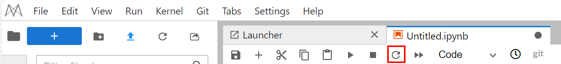

步骤3 修改配置文件
- 切换当前目录，修改配置文件，将数据集文件路径传入，并定义数据类别
输入：
%cd /home/ma-user/work/code
import os
import yaml
dataset_path = os.getcwd().replace('/code','/pcb_data') #注意：此处建议写成绝对路径，避免数据集加载出错
class_names_list = ['open','short','mousebite','spur','copper','pin-hole']
with open("pcb-detect.yaml", 'r', encoding='utf-8') as yaml_file:
content = yaml.load(yaml_file, yaml.FullLoader)
content['path'] = dataset_path
content['train'] = 'images/train2017'
content['val'] = 'images/val2017'
content['nc'] = len(class_names_list)
content['names'] = class_names_list
content['download'] = None
with open("pcb-detect.yaml", 'w', encoding='utf-8') as f:
yaml.dump(content, f)
输出：
/home/ma-user/work/code

步骤4 训练
输入：
from ultralytics import YOLO
# 加载模型
model = YOLO("yolov8n.pt") # 加载预训练模型（建议用于训练）
# 使用模型
model.train(data="pcb-detect.yaml", epochs=10, imgsz=640) # 训练模型
metrics = model.val() # 在验证集上评估模型性能
输出：
/home/ma-user/anaconda3/envs/PyTorch-1.8/lib/python3.7/site-packages/requests/__init__.py:104: RequestsDependencyWarning: urllib3 (1.26.12) or chardet (5.2.0)/charset_normalizer (2.0.12) doesn't match a supported version!
RequestsDependencyWarning)
/home/ma-user/anaconda3/envs/PyTorch-1.8/lib/python3.7/site-packages/tqdm/auto.py:22: TqdmWarning: IProgress not found. Please update jupyter and ipywidgets. See https://ipywidgets.readthedocs.io/en/stable/user_install.html
from .autonotebook import tqdm as notebook_tqdm
WARNING ⚠️ Ultralytics settings reset to defaults. This is normal and may be due to a recent ultralytics package update, but may have overwritten previous settings.
View and update settings with 'yolo settings' or at '/home/ma-user/.config/Ultralytics/settings.yaml'
Ultralytics YOLOv8.0.109 🚀 Python-3.7.10 torch-1.8.0 CUDA:0 (Tesla P100-PCIE-16GB, 16281MiB)
WARNING ⚠️ Upgrade to torch>=2.0.0 for deterministic training.
yolo/engine/trainer: task=detect, mode=train, model=yolov8n.pt, data=pcb-detect.yaml, epochs=10, patience=50, batch=16, imgsz=640, save=True, save_period=-1, cache=False, device=None, workers=8, project=None, name=None, exist_ok=False, pretrained=False, optimizer=SGD, verbose=True, seed=0, deterministic=True, single_cls=False, rect=False, cos_lr=False, close_mosaic=0, resume=False, amp=True, overlap_mask=True, mask_ratio=4, dropout=0.0, val=True, split=val, save_json=False, save_hybrid=False, conf=None, iou=0.7, max_det=300, half=False, dnn=False, plots=True, source=None, show=False, save_txt=False, save_conf=False, save_crop=False, show_labels=True, show_conf=True, vid_stride=1, line_width=None, visualize=False, augment=False, agnostic_nms=False, classes=None, retina_masks=False, boxes=True, format=torchscript, keras=False, optimize=False, int8=False, dynamic=False, simplify=False, opset=None, workspace=4, nms=False, lr0=0.01, lrf=0.01, momentum=0.937, weight_decay=0.0005, warmup_epochs=3.0, warmup_momentum=0.8, warmup_bias_lr=0.1, box=7.5, cls=0.5, dfl=1.5, pose=12.0, kobj=1.0, label_smoothing=0.0, nbs=64, hsv_h=0.015, hsv_s=0.7, hsv_v=0.4, degrees=0.0, translate=0.1, scale=0.5, shear=0.0, perspective=0.0, flipud=0.0, fliplr=0.5, mosaic=1.0, mixup=0.0, copy_paste=0.0, cfg=None, v5loader=False, tracker=botsort.yaml, save_dir=runs/detect/train
Overriding model.yaml nc=80 with nc=6
from n params module arguments
0 -1 1 464 ultralytics.nn.modules.conv.Conv [3, 16, 3, 2]
1 -1 1 4672 ultralytics.nn.modules.conv.Conv [16, 32, 3, 2]
2 -1 1 7360 ultralytics.nn.modules.block.C2f [32, 32, 1, True]
3 -1 1 18560 ultralytics.nn.modules.conv.Conv [32, 64, 3, 2]
4 -1 2 49664 ultralytics.nn.modules.block.C2f [64, 64, 2, True]
5 -1 1 73984 ultralytics.nn.modules.conv.Conv [64, 128, 3, 2]
6 -1 2 197632 ultralytics.nn.modules.block.C2f [128, 128, 2, True]
7 -1 1 295424 ultralytics.nn.modules.conv.Conv [128, 256, 3, 2]
8 -1 1 460288 ultralytics.nn.modules.block.C2f [256, 256, 1, True]
9 -1 1 164608 ultralytics.nn.modules.block.SPPF [256, 256, 5]
10 -1 1 0 torch.nn.modules.upsampling.Upsample [None, 2, 'nearest']
11 [-1, 6] 1 0 ultralytics.nn.modules.conv.Concat [1]
12 -1 1 148224 ultralytics.nn.modules.block.C2f [384, 128, 1]
...
copper 500 464 0.977 0.935 0.979 0.8
pin-hole 500 470 0.871 0.957 0.976 0.733
Speed: 0.4ms preprocess, 2.5ms inference, 0.0ms loss, 2.0ms postprocess per image
Results saved to runs/detect/val
训练后的模型会保存到runs/detect/train文件夹中，您可以自行查看。

步骤5 预测
调用代码自带的预测脚本，加载任意图片进行预测。
输入：
import os
import cv2
from matplotlib import pyplot as plt
%matplotlib inline
results = model("00041204.jpg" , save=True) # 对图像进行预测
save_dir = 'runs/detect/predict/00041204.jpg'
img = cv2.imread(save_dir)
img = img[:, :, ::-1]
plt.axis('off')
plt.imshow(img)
plt.show()
输出：
image 1/1 /home/ma-user/work/code/00041204.jpg: 640x640 1 open, 1 short, 1 mousebite, 1 spur, 1 copper, 1 pin-hole, 14.0ms
Speed: 1.9ms preprocess, 14.0ms inference, 2.8ms postprocess per image at shape (1, 3, 640, 640)
Results saved to runs/detect/predict
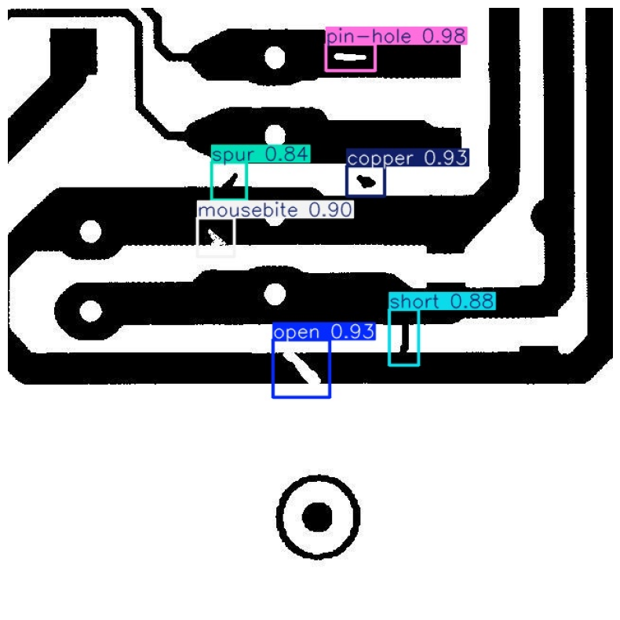

预测的结果保存路径会在日志中打印出来，您可以自行点击查看。

任务三：创建训练作业准备
在跑通Yolov8的在线训练后，可以编写代码实现在ModelArts平台上创建训练作业，并统一对训练作业进行管理。
创建训练作业的整体逻辑如下：
- 修改训练代码，将训练的输入、输出以参数的形式暴露出来，以供ModelArts调用。
- 在ModelArts创建算法/训练作业时，将暴露的参数在训练输入、输出和超参中配置。
ModelArts在开始训练时，默认会在训练启动脚本后将配置的参数，以--XXX的形式放在启动脚本之后，因此只要确保脚本支持--XXX的形式解析参数即可。

步骤1 编写训练代码
- 当前在Notebook的code文件夹下，已经准备好训练相关代码，其中核心的代码文件介绍如下：
├── code
├─train.py # yolov8训练文件
├─requirement.txt # 训练启动时安装的依赖库文件
├─train # 训练额外需要的文件
├─voc.yaml # yolov8原始数据集配置文件
├─voc_cache.yaml # 基于外部传参修改的数据集配置文件
├─config.json # ModelArts推理配置文件（仅部署时使用）
├─customize_service.py # ModelArts推理自定义服务文件（仅部署时使用）
- 下面我们重点来看下训练文件-train.py的写法：
整体代码逻辑如下：
①首先定义代码中所需变量
②将--XXX的参数传入，更新代码变量的参数
③更新数据集配置文件
④进行训练和验证
⑤拷贝训练结果和推理部署相关文件到输出文件夹
- 具体代码如下：
import os
import argparse
import sys
import yaml
import moxing as mox
import shutil
from ultralytics import YOLO
if __name__ == "__main__":
app_url = os.path.dirname(__file__)
sys.path.insert(0, os.path.dirname(__file__))
parser = argparse.ArgumentParser(description="train yolov8")
parser.add_argument("--data_url", type=str, required=True)#训练数据集输入路径，yolo格式
parser.add_argument("--train_url", type=str, required=True)#训练模型输出路径
parser.add_argument("--imgsz", type=int, default=640)#训练图片尺寸
parser.add_argument("--epochs", type=int, default=100)#训练轮次
parser.add_argument("--batch", type=int, default=16)#训练批次数
parser.add_argument("--class_names", type=str, default='person,bicycle')#类别定义，字符串，多个类别以逗号隔开，中间不能有空格
args = parser.parse_args()
class_names_list = args.class_names.split(',')
current_path = os.getcwd()
if not os.path.exists(os.path.join(current_path, "yolov8n.pt")):
#yolov8源码会检测运行目录下是否有yolov8n.pt，如没有则会从网上下载；而ModelArts训练环境无法下载，因此复制到运行目录下
shutil.copy(os.path.join(app_url, "yolov8n.pt"), os.path.join(current_path, "yolov8n.pt"))
#更新数据集配置文件
with open(os.path.join(app_url, "train", "voc.yaml"), 'r', encoding='utf-8') as yaml_file:
content = yaml.load(yaml_file, yaml.FullLoader)
content['download'] = None
content['train'] = 'images/train2017'
content['val'] = 'images/val2017'
content['nc'] = len(class_names_list)
content['names'] = class_names_list
content['path'] = args.data_url
with open(os.path.join(app_url, "train", "voc_cache.yaml"), 'w', encoding='utf-8') as f:
yaml.dump(content, f)
#进行训练
model = YOLO("yolov8n.pt")
model.train(data=os.path.join(app_url, "train", "voc_cache.yaml"), epochs=args.epochs, imgsz=args.imgsz,
batch=args.batch, project=args.train_url)
metrics = model.val()
#拷贝训练产物
mox.file.make_dirs(os.path.join(args.train_url, "model"))
mox.file.copy(os.path.join(app_url, "train", "config.json"), os.path.join(args.train_url, "model", "config.json"))
mox.file.copy(os.path.join(app_url, "train", "customize_service.py"),
os.path.join(args.train_url, "model", "customize_service.py"))
mox.file.copy(os.path.join(args.train_url, "train", "weights", "best.pt"),
os.path.join(args.train_url, "model", "best.pt"))

步骤2 本地测试
在任务二创建的ipynb文件中，新增一个cell，复制以下代码并运行，进行在线测试，由于notebook中仅支持单卡训练，当前采用单卡训练方式进行测试。
输入：
%cd /home/ma-user/work/code
import os
dataset_path = os.getcwd().replace('/code','/pcb_data') #注意：此处建议写成绝对路径，避免数据集加载出错
!python train.py --data_url {dataset_path} --train_url 'output' --imgsz 640 \
--epochs 10 --batch 16 --class_names 'open,short,mousebite,spur,copper,pin-hole'
输出：
/home/ma-user/work/code
INFO:root:Using MoXing-v2.1.0.5d9c87c8-5d9c87c8
INFO:root:Using OBS-Python-SDK-3.20.9.1
/home/ma-user/anaconda3/envs/PyTorch-1.8/lib/python3.7/site-packages/requests/__init__.py:104: RequestsDependencyWarning: urllib3 (1.26.12) or chardet (5.2.0)/charset_normalizer (2.0.12) doesn't match a supported version!
RequestsDependencyWarning)
Ultralytics YOLOv8.0.109 🚀 Python-3.7.10 torch-1.8.0 CUDA:0 (Tesla P100-PCIE-16GB, 16281MiB)
WARNING ⚠️ Upgrade to torch>=2.0.0 for deterministic training.
yolo/engine/trainer: task=detect, mode=train, model=yolov8n.pt, data=train/voc_cache.yaml, epochs=10, patience=50, batch=16, imgsz=640, save=True, save_period=-1, cache=False, device=None, workers=8, project=output, name=None, exist_ok=False, pretrained=False, optimizer=SGD, verbose=True, seed=0, deterministic=True, single_cls=False, rect=False, cos_lr=False, close_mosaic=0, resume=False, amp=True, overlap_mask=True, mask_ratio=4, dropout=0.0, val=True, split=val, save_json=False, save_hybrid=False, conf=None, iou=0.7, max_det=300, half=False, dnn=False, plots=True, source=None, show=False, save_txt=False, save_conf=False, save_crop=False, show_labels=True, show_conf=True, vid_stride=1, line_width=None, visualize=False, augment=False, agnostic_nms=False, classes=None, retina_masks=False, boxes=True, format=torchscript, keras=False, optimize=False, int8=False, dynamic=False, simplify=False, opset=None, workspace=4, nms=False, lr0=0.01, lrf=0.01, momentum=0.937, weight_decay=0.0005, warmup_epochs=3.0, warmup_momentum=0.8, warmup_bias_lr=0.1, box=7.5, cls=0.5, dfl=1.5, pose=12.0, kobj=1.0, label_smoothing=0.0, nbs=64, hsv_h=0.015, hsv_s=0.7, hsv_v=0.4, degrees=0.0, translate=0.1, scale=0.5, shear=0.0, perspective=0.0, flipud=0.0, fliplr=0.5, mosaic=1.0, mixup=0.0, copy_paste=0.0, cfg=None, v5loader=False, tracker=botsort.yaml, save_dir=output/train
Overriding model.yaml nc=80 with nc=6
from n params module arguments
0 -1 1 464 ultralytics.nn.modules.conv.Conv [3, 16, 3, 2]
1 -1 1 4672 ultralytics.nn.modules.conv.Conv [16, 32, 3, 2]
2 -1 1 7360 ultralytics.nn.modules.block.C2f [32, 32, 1, True]
3 -1 1 18560 ultralytics.nn.modules.conv.Conv [32, 64, 3, 2]
4 -1 2 49664 ultralytics.nn.modules.block.C2f [64, 64, 2, True]
5 -1 1 73984 ultralytics.nn.modules.conv.Conv [64, 128, 3, 2]
6 -1 2 197632 ultralytics.nn.modules.block.C2f [128, 128, 2, True]
7 -1 1 295424 ultralytics.nn.modules.conv.Conv [128, 256, 3, 2]
8 -1 1 460288 ultralytics.nn.modules.block.C2f [256, 256, 1, True]
9 -1 1 164608 ultralytics.nn.modules.block.SPPF [256, 256, 5]
10 -1 1 0 torch.nn.modules.upsampling.Upsample [None, 2, 'nearest']
11 [-1, 6] 1 0 ultralytics.nn.modules.conv.Concat [1]
12 -1 1 148224 ultralytics.nn.modules.block.C2f [384, 128, 1]
13 -1 1 0 torch.nn.modules.upsampling.Upsample [None, 2, 'nearest']
14 [-1, 4] 1 0 ultralytics.nn.modules.conv.Concat [1]
...
copper 500 464 0.99 0.905 0.971 0.798
pin-hole 500 470 0.811 0.972 0.949 0.691
Speed: 0.4ms preprocess, 2.5ms inference, 0.0ms loss, 5.0ms postprocess per image
Results saved to output/val
验证的结果也保存在output/val文件夹中，您可以自行点击查看。

步骤3 将训练代码和数据集上传至OBS桶
继续在ipynb文件中，输入以下代码作为示例运行，特别注意，示例代码中ll-test需要改成任务一步骤一创建的OBS桶名称。
import moxing as mox
mox.file.copy_parallel('/home/ma-user/work/code','obs://ll-test/code')
mox.file.copy_parallel('/home/ma-user/work/pcb_data','obs://ll-test/pcb_data')
运行完成后，代码左侧会显示运行耗时，同时在OBS对象存储服务中，看到新创建的code和pcb_data文件夹。
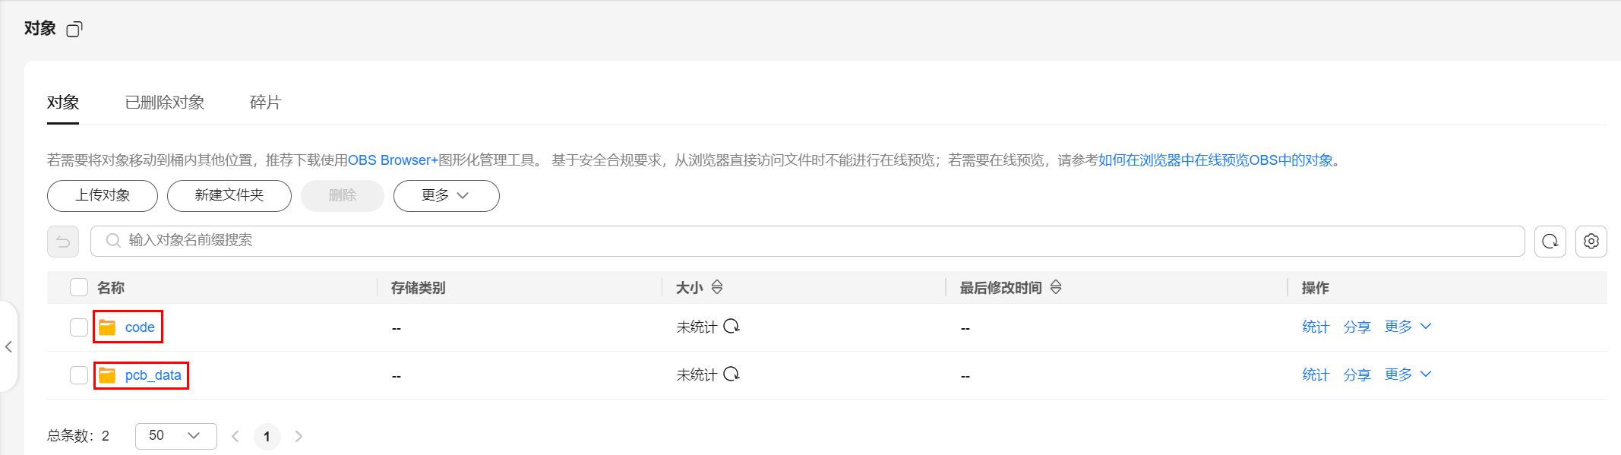

步骤4 创建输出目录
在OBS对象存储服务中，点击新建文件夹，创建名为output的输出目录。
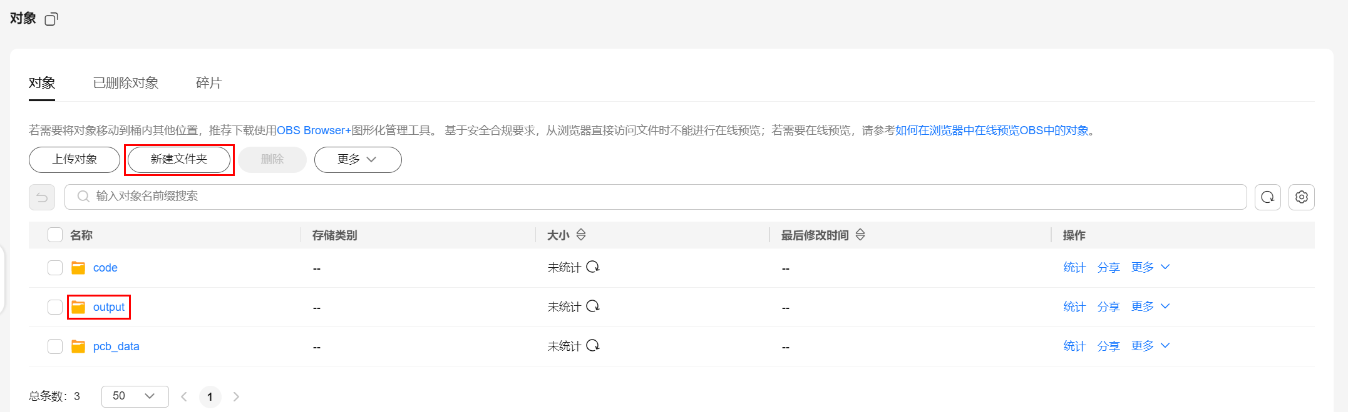

任务四：创建训练作业

步骤1 创建算法
- 点击左侧“算法管理”，点击“创建”
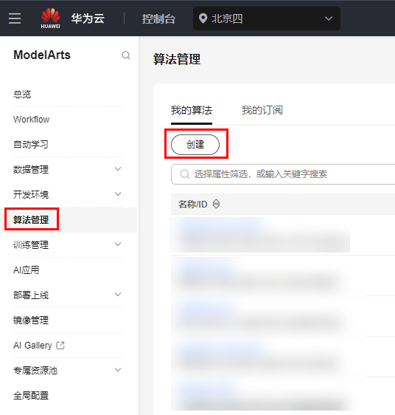
- 配置参数参考下图：
名称：自定义，如algorithm-pcb-yolov8
启动方式：预置框架--PyTorch--pytorch1.8.0-cuda10.2-py3.7-ubuntu18.04-x86_64
代码目录：任务三的步骤3上传的训练代码目录
启动文件：代码目录中的train.py文件
管道设置：
输入->参数名称->data_url
输出->参数名称->train_url
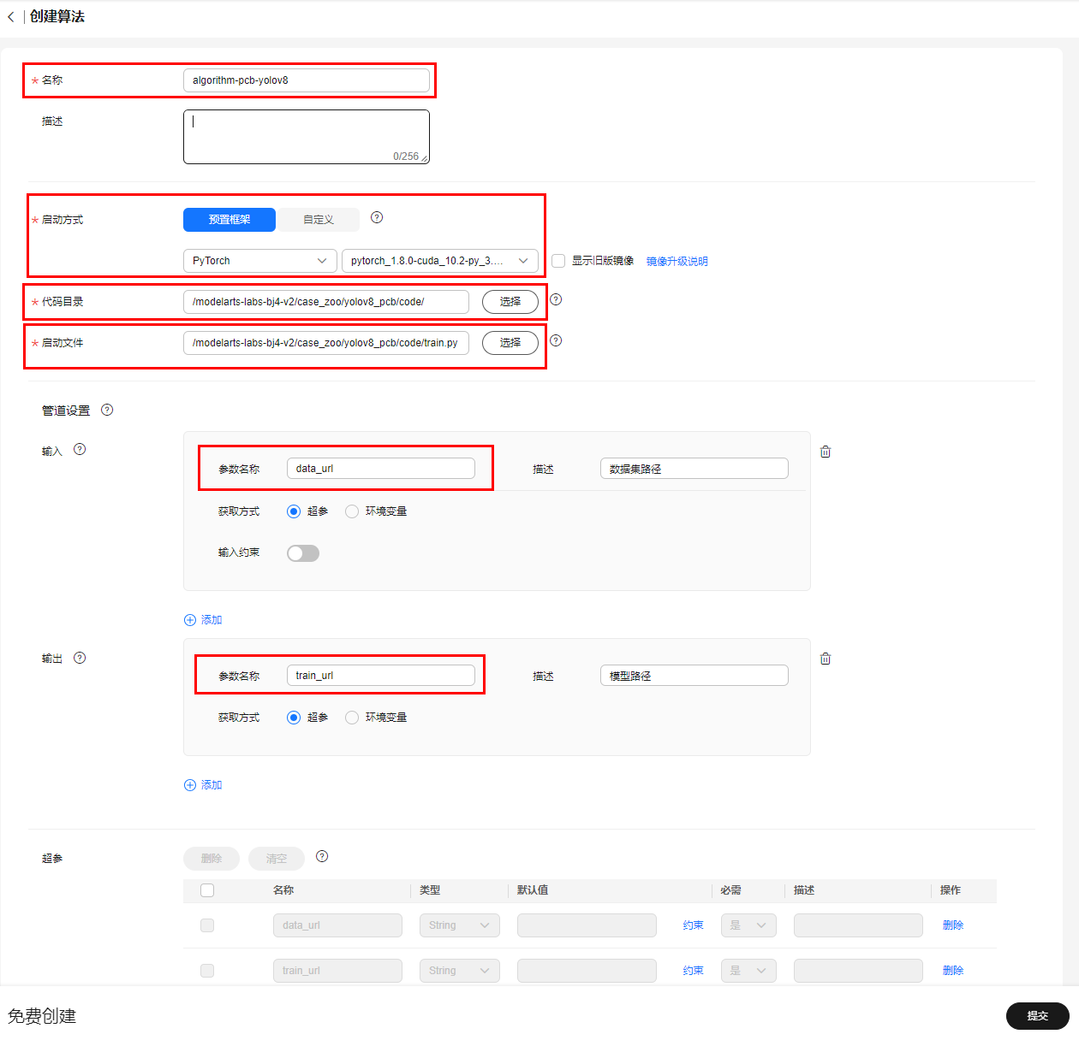

超参：
参数 | 值
imgsz | 640
epochs | 10
batch | 16
class_names | open,short,mousebite,spur,copper,pin-hole
训练策略：不添加
- 点击提交，进行算法创建。

步骤2 创建训练作业
- 完成算法创建后，选择刚刚创建好的算法，点击右侧创建训练作业。

进入创建训练作业页面，可以自行配置训练的名称，下方会默认选择刚刚创建的算法。
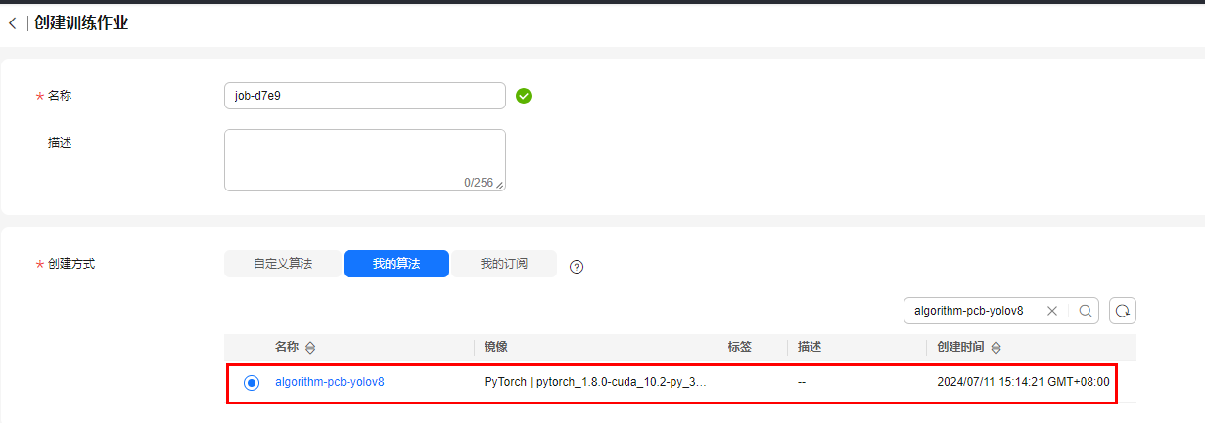
- 配置训练参数，具体参数说明如下：
名称 | 值 | 类型 | 是否必填 | 是否可修改 | 描述
data_url | 任务三的步骤3上传的数据集目录 | String | 是 | 是 | 输入数据obs路径,可以使用yolo格式数据集
train_url | 需要输出到的obs目录，请自行在obs桶内创建目录并填入 | String | 是 | 是 | 输出数据obs路径
imgsz | 640 | Integer | 是 | 是 | 图片尺寸
epochs | 10 | Integer | 是 | 是 | 训练轮次
batch | 16 | Integer | 是 | 是 | 单批次处理图片数目
class_names | open,short,mousebite,spur,copper,pin-hole | String | 是 | 是 | 数据集类别名称(类别以逗号分隔开,注意中间不能有空格)
如下图所示，完成参数配置：
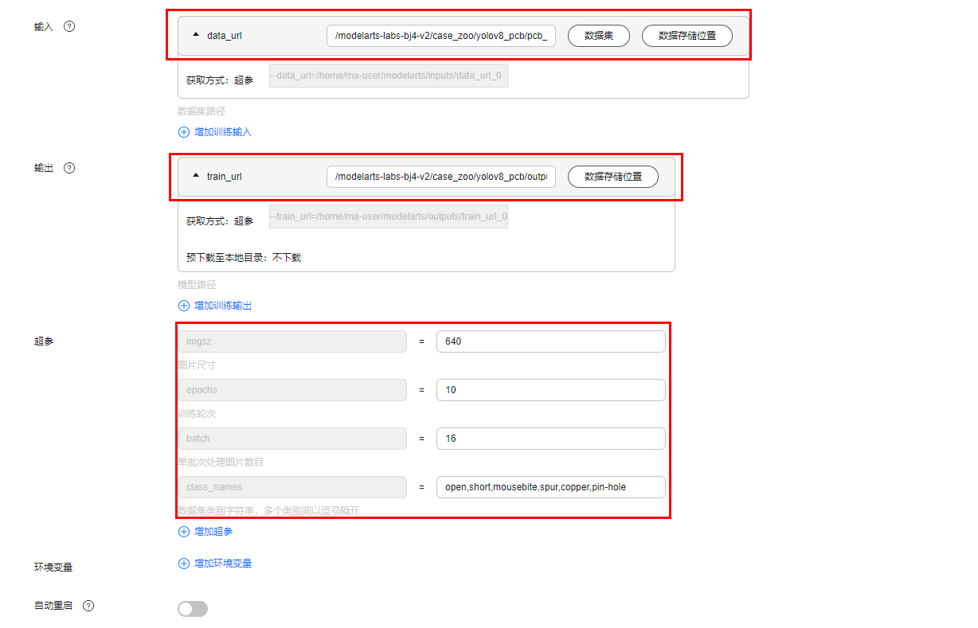
- 选择公共资源池，资源类型为GPU，规格为*
GPU: 1GP-Vnt1(32GB) | CPU: 8 核 64GB 3200GB，点击提交**。
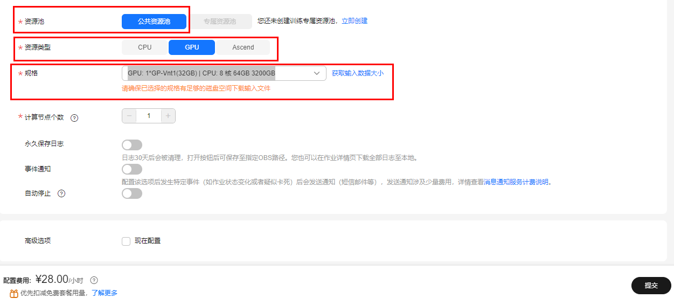

- 在弹出的页面中确认当前训练作业的参数配置，确认无误，点击确定完成创建。
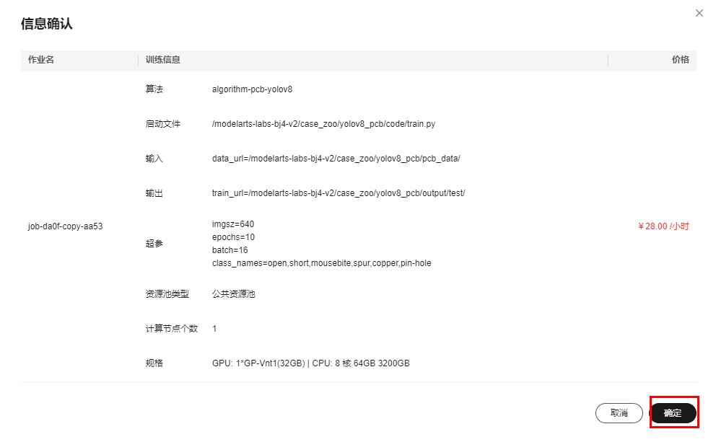

步骤3 查看训练状态
- 点击训练作业名称，进入训练作业详情页面。
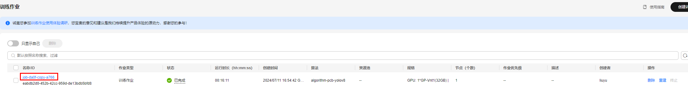
- 在训练作业详情页面，可以点击日志标签页，查看训练的具体输出，例如mAP等信息。
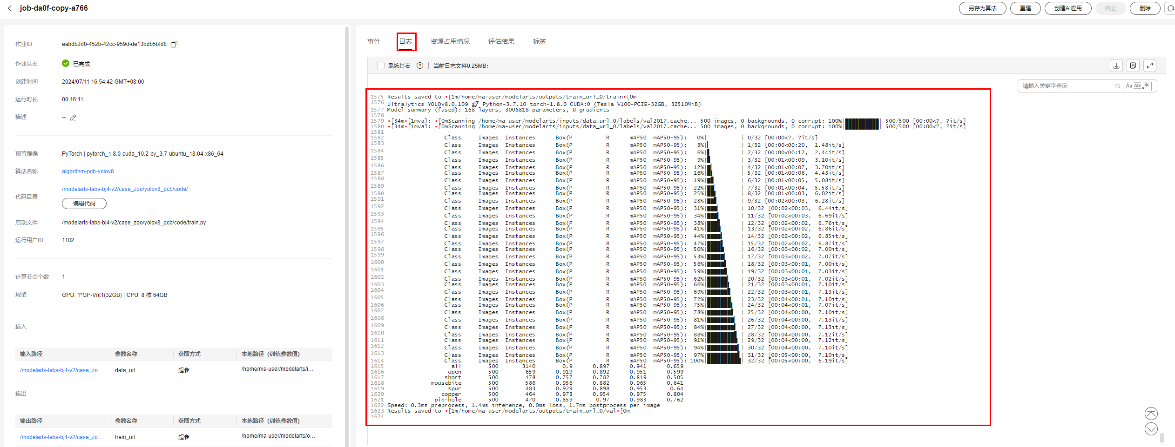
- 在训练作业详情页面，可以点击资源占用情况标签页，查看训练的各项资源占用，观察训练状态。
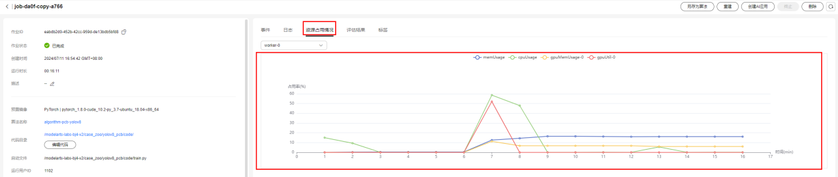

步骤4 训练输出文件
在训练结束后，训练生成的模型等文件会自动传输到train_url对应的目录中，目录中文件内容如下所示：
├── 训练输出目录
├─config.json # ModelArts推理配置文件
├─customize_service.py # ModelArts推理自定义服务文件
├─best.pt # yolov8模型文件

任务五：模型部署准备
在完成任务二的Yolov8的预测部分后，在ModelArts服务中可以将AI模型创建为AI应用，然后将AI应用快速部署为在线推理服务，流程图如下所示：
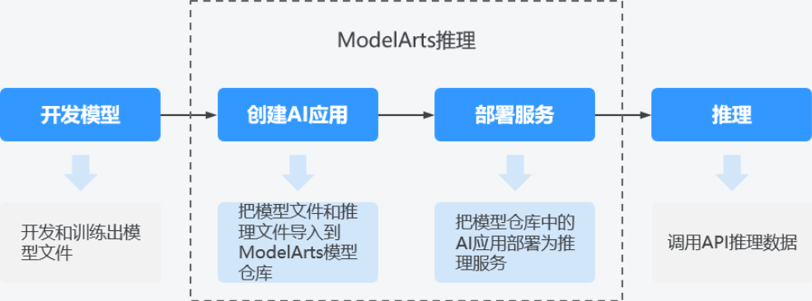
◉ 开发模型：模型开发可以在ModelArts服务中进行，也可以在您的本地开发环境进行。
◉ 创建AI应用：把模型文件、配置文件和推理文件导入到ModelArts的模型仓库中，进行版本化管理，并构建为可运行的AI应用。
◉ 部署服务：把AI应用在资源池中部署为容器实例，注册外部可访问的推理API。
◉ 推理：在您的应用中增加对推理API的调用，在业务流程中集成AI推理能力。

步骤1 编写推理代码

推理代码格式
- 当前在Notebook的code/output/model路径下，已经准备好推理相关的代码。
- 刚刚完成的训练作业已将推理相关的代码上传至了自建obs桶的output/model目录中。
- model目录具体代码结构如下：
├── 训练输出目录
├─config.json # ModelArts推理配置文件
├─customize_service.py # ModelArts推理自定义服务文件
├─best.pt # yolov8模型文件
其中best.pt则是训练得到的模型文件，您也可以从其他地方下载替换。
- 下面重点介绍config.json、customize_service.py文件的写法。

推理配置文件-config.json
本文件包含模型部署的运行环境和依赖库，以及部署上线后模型的输入输出，具体的内容您可以双击文件查看。

推理自定义服务文件-customize_service.py
- 导包
1) 在模型代码推理文件“customize_service.py”中，需要添加一个子类，该子类继承对应模型PyTorch类型的父类PTServingBaseService,导入语句如下所示:
try:
from model_service.pytorch_model_service import PTServingBaseService
except:
PTServingBaseService = object
2) 加载模型推理所依赖的包
import os
from ultralytics import YOLO
import logging
import torch
import cv2
import numpy as np
- 重写方法
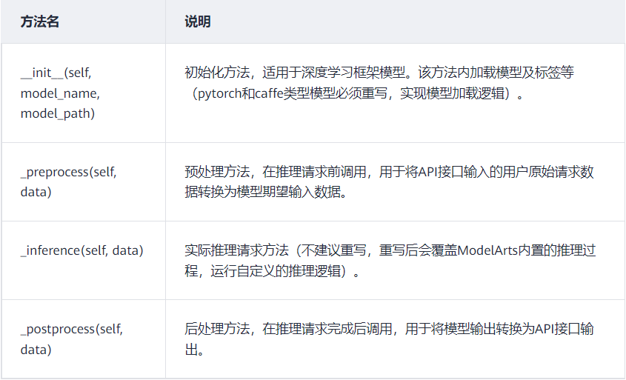

1) 重写初始化方法
此方法用于初始化和加载预训练模型。首先需要构建一个类，这个类应当继承PTServingBaseService，且需定义模型配置文件路径及模型路径。
class CustomizeService(PTServingBaseService):
def __init__(self, model_name, model_path):
self.device = 'cuda' if torch.cuda.is_available() else 'cpu'
if torch.cuda.is_available():
logger.info('Using GPU for inference')
else:
logger.info('Using CPU for inference')
print(f'running on {self.device}')
self.code_url = os.path.dirname(os.path.abspath(__file__))
self.model = YOLO(os.path.join(self.code_url, "best.pt"))
self.model.to(torch.device(self.device))
self.labels = self.model.module.name if hasattr(self.model, 'module') else self.model.names
2) 重写预处理方法
此方法对自定义图像进行预处理，实际推理请求方法和后处理方法中的接口传入“data”当前支持两种content-type，即“multipart/form-data”和“application/json”。此处定义传入参数data为multipart/form-data类型。
首先加载图片，将其保存内存中用于后续推理。
def _preprocess(self, data):
data_list = []
for _, v in data.items():
for _, file_content in v.items():
file_content = file_content.read()
img = cv2.imdecode(np.frombuffer(file_content, np.uint8), cv2.IMREAD_COLOR)
data_list.append(img)
return data_list
3) 重写推理方法
调用Yolov8模型进行推理，并返回推理结果。
def _inference(self, data):
with torch.no_grad():
data = self.model(data[0])
return data
4) 重写后处理方法
此方法对推理输出的数据进行后处理操作，按照预置物体检测模式输出。
推理结果以“JSON”体的形式返回，detectionclasses是每个检测框的标签，detectionboxes是每个检测框的四点坐标（ymin,xmin,ymax,xmax），detection_scores是每个检测框的置信度。
def _postprocess(self, data):
result_return = dict()
data = data[0].to(torch.device('cpu'))
boxes = data.boxes
if data is not None:
boxes = data.boxes
picked_boxes = [[box[1], box[0], box[3], box[2]] for box in boxes.xyxy.tolist()]
picked_classes = self.convert_labels(boxes.cls)
picked_score = boxes.conf
result_return['detection_classes'] = picked_classes
result_return['detection_boxes'] = picked_boxes
result_return['detection_scores'] = picked_score.tolist()
else:
result_return['detection_classes'] = []
result_return['detection_boxes'] = []
result_return['detection_scores'] = []
return result_return
def convert_labels(self, label_list):
if isinstance(label_list, np.ndarray):
label_list = label_list.tolist()
label_names = [self.labels[int(index)] for index in label_list]
return label_names
编写完推理脚本后，点CRTL+S进行保存。

步骤2 本地测试
在任务二创建的ipynb文件中，新增一个cell，复制以下代码并运行，进行在线测试。
输入：
%cd /home/ma-user/work/code/output/model
import os
from customize_service import CustomizeService
test_path = "/home/ma-user/work/code/00041204.jpg"
service = CustomizeService(model_name="yolov8", model_path="best.pt")
post_data = {"input_txt": {os.path.basename(test_path): open(test_path, "rb")}}
file_data = service._preprocess(post_data)
detect_data = service._inference(file_data)
result = service._postprocess(detect_data)
print('result:',result)
输出：
/home/ma-user/work/code/output/model
2024-07-11 16:38:52,848 - customize_service - INFO - Using GPU for inference
2024-07-11 16:38:52 CST [MainThread ] - /home/ma-user/work/code/output/model/customize_service.py[line:22] - INFO: Using GPU for inference []
0: 640x640 1 open, 1 short, 1 mousebite, 2 spurs, 1 copper, 2 pin-holes, 7.5ms
Speed: 1.7ms preprocess, 7.5ms inference, 1.9ms postprocess per image at shape (1, 3, 640, 640)
running on cuda
result: {'detection_classes': ['pin-hole', 'short', 'mousebite', 'spur', 'copper', 'open', 'spur', 'pin-hole'], 'detection_boxes': [[37.003761291503906, 332.63702392578125, 67.1460189819336, 391.19732666015625], [319.14727783203125, 403.04034423828125, 378.45428466796875, 435.96990966796875], [221.5313720703125, 198.52035522460938, 266.8993835449219, 242.41287231445312], [163.58485412597656, 214.45738220214844, 204.06224060058594, 254.59532165527344], [165.648193359375, 357.467529296875, 202.36322021484375, 399.8277587890625], [349.1726379394531, 278.495361328125, 411.7776184082031, 343.18096923828125], [191.37081909179688, 541.1957397460938, 250.84710693359375, 589.4989624023438], [194.25131225585938, 257.96563720703125, 242.24270629882812, 305.7176513671875]], 'detection_scores': [0.9690598845481873, 0.9391624927520752, 0.9367893934249878, 0.9264795184135437, 0.9203583598136902, 0.8005935549736023, 0.5658920407295227, 0.4303133189678192]}
更多有关模型推理代码编写说明可参考：https://support.huaweicloud.com/inference-modelarts/inference-modelarts-0057.html

任务六：创建AI应用并部署成在线服务

步骤1 创建AI应用
点击左侧“AI应用管理 >AI应用”，点击“创建”
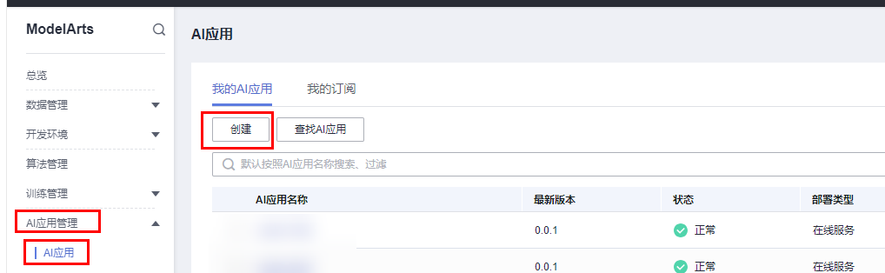
配置参数参考下图：
名称：自定义，如model-yolov8-pcb
版本：默认
元模型来源：从训练中选择
选择训练作业：在下拉框中选择刚刚创建并训练完成的训练作业。
其余参数：保持默认
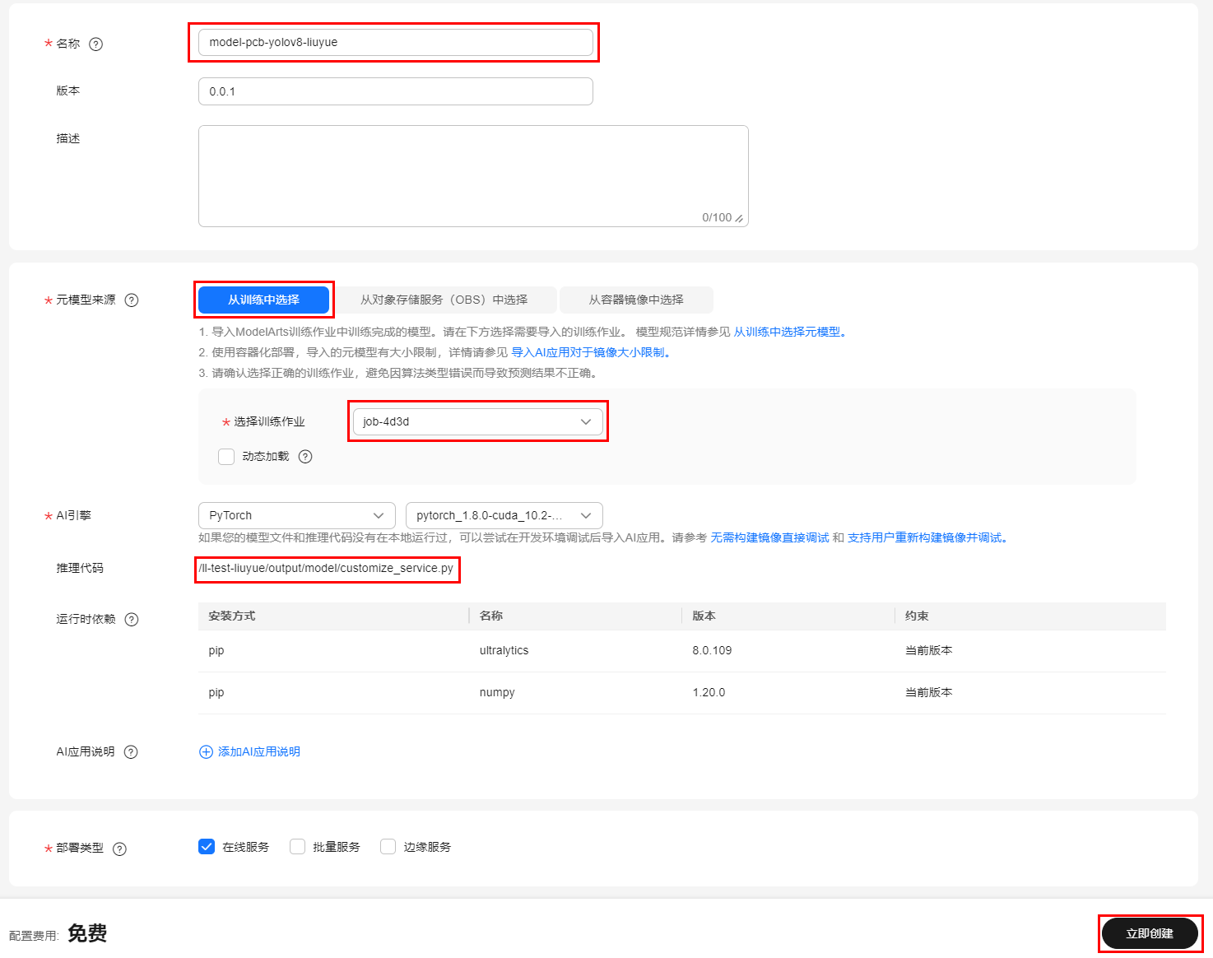

点击立即创建，进行AI应用创建。
创建AI应用的更多细节可参考文档https://support.huaweicloud.com/api-modelarts/CreateModel.html

步骤2 部署成在线服务
- 等待AI应用创建完毕后，即应用列表状态变为正常，选中创建好的AI应用，在下方右侧操作栏依次点击部署、在线服务。
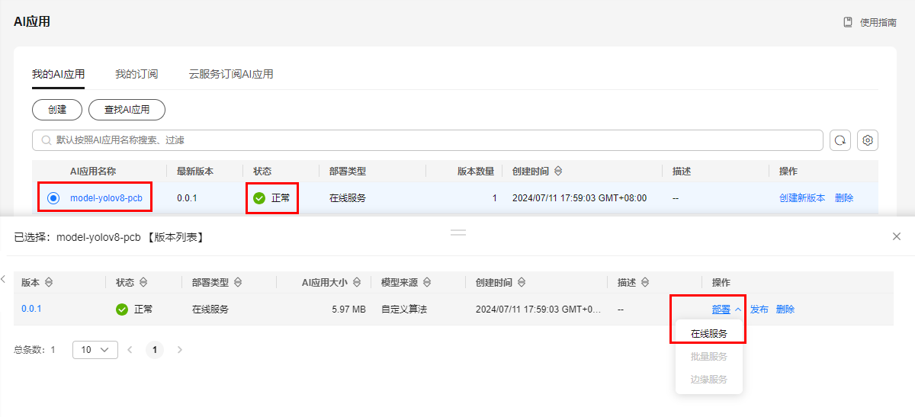
- 在弹出的部署页面中，可以修改部署服务的名称，部署时长等信息。
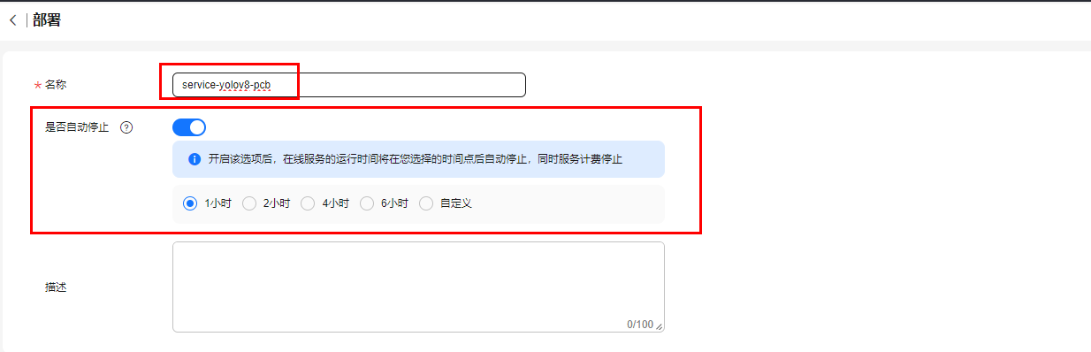
- 将页面往下滑动，修改资源池为公共资源池，并选中计算节点规格为CPU: 2 核 8GB，其他参数保持不变，点击下一步。
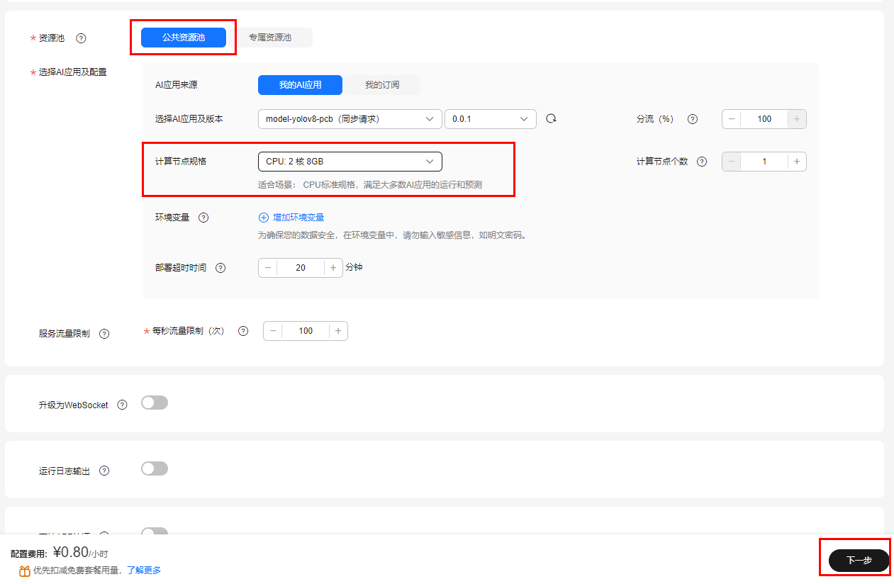
- 查看当前创建在线服务参数是否有误，如无问题，点击提交按钮
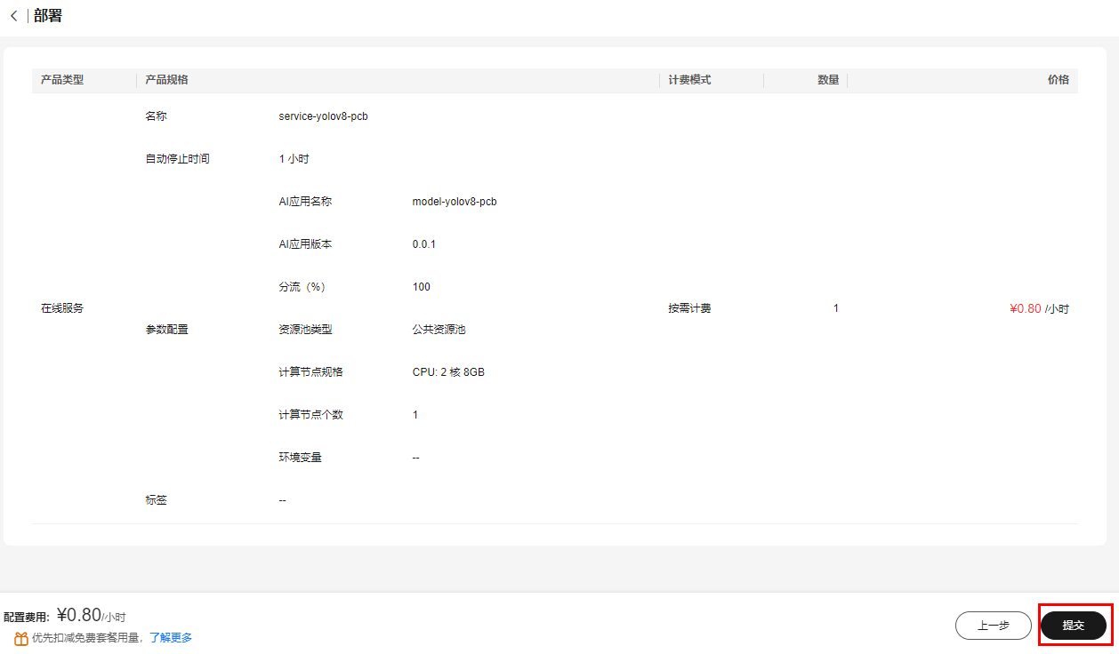
- 在弹出的页面中，点击查看服务详情，进入服务页面。
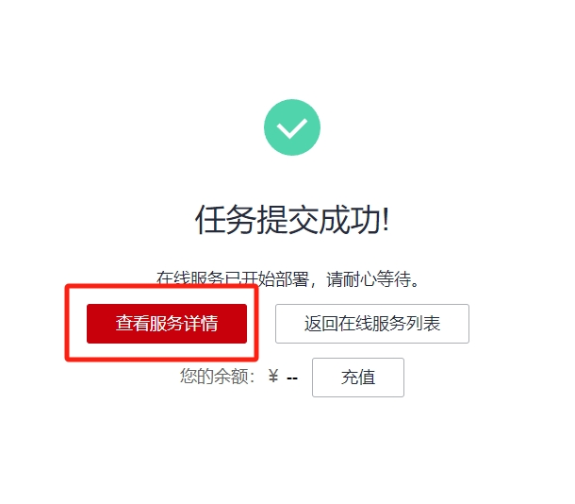

步骤3 推理测试
- 可以将测试图片保存到本地。
- 进入服务页面后，等待服务状态变为运行中，点击下方的预测标签页。
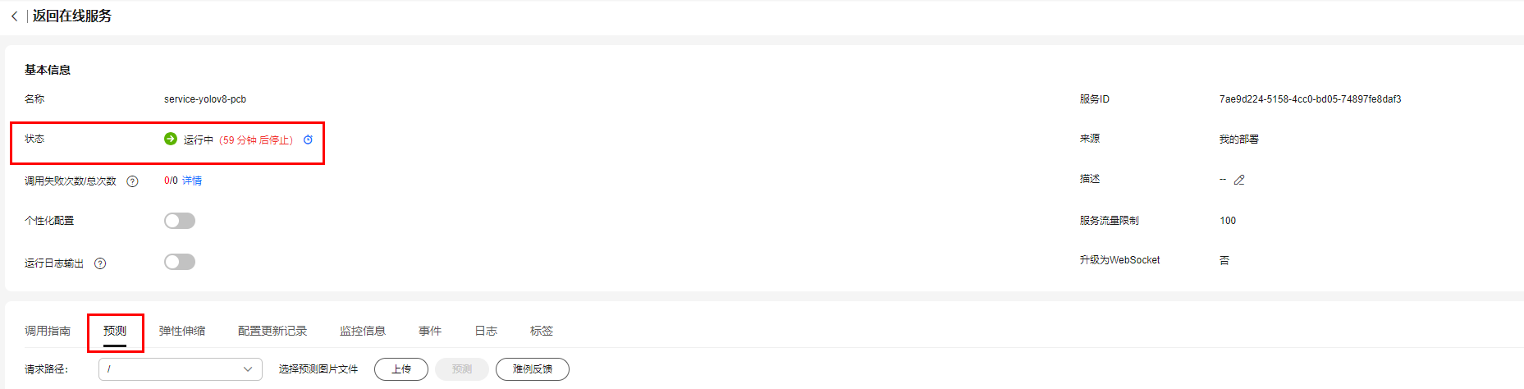
- 上传图片，并点击右侧的预测按钮，进行预测。
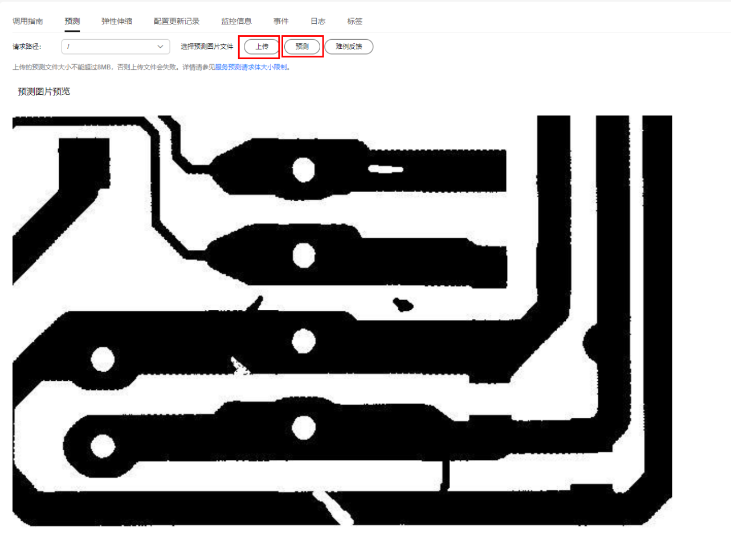
- 预测结果会显示在右侧，并实时在图片上进行标注。
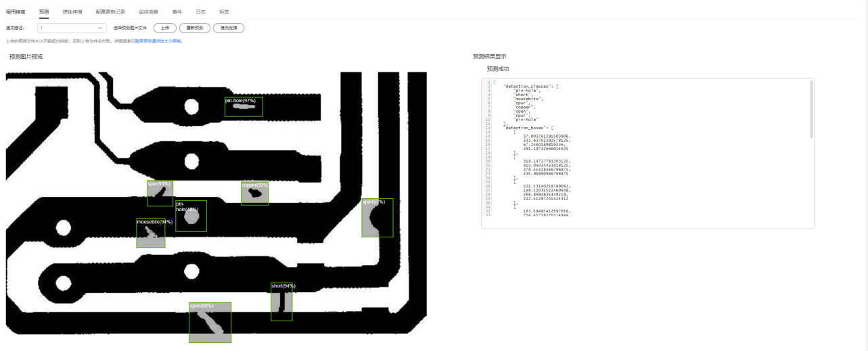
- 完成预测后，注意点击右上角停止按钮，停止在线服务运行，释放资源。
